**Criterion C: Development**

**Fulfilling The Success Criteria**

I have achieved all the success criteria by creating the application on VScode by python language and using a module called Tkinter and all the source code is attached in **Appendix-2** for reference.

Linked with success criteria 1

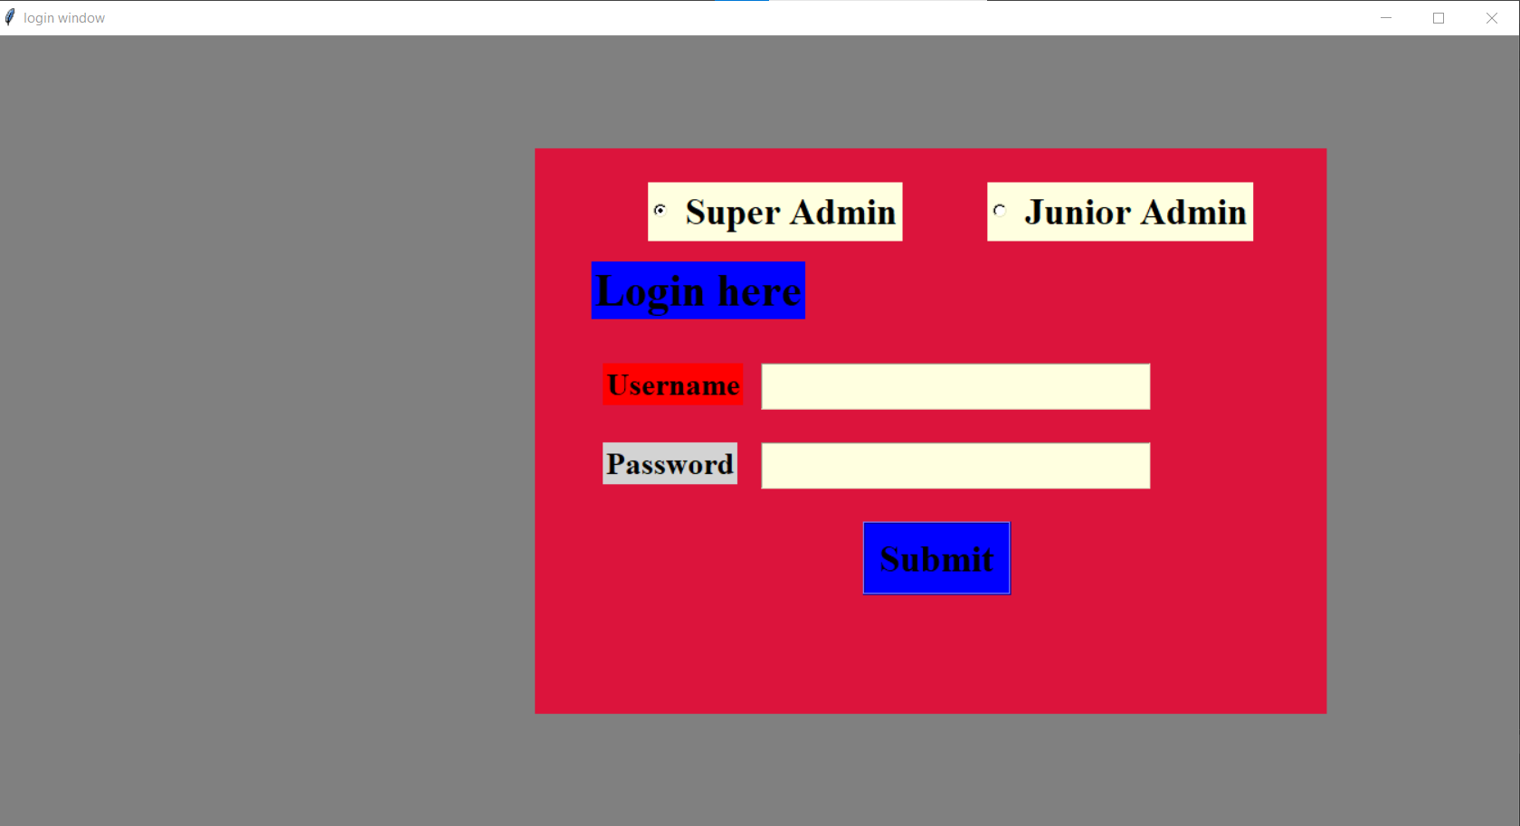



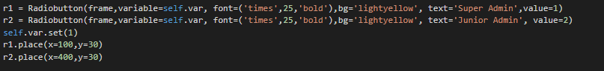

Linked with success criteria 2

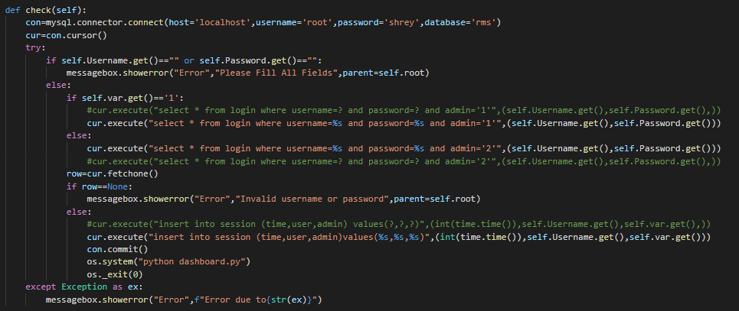

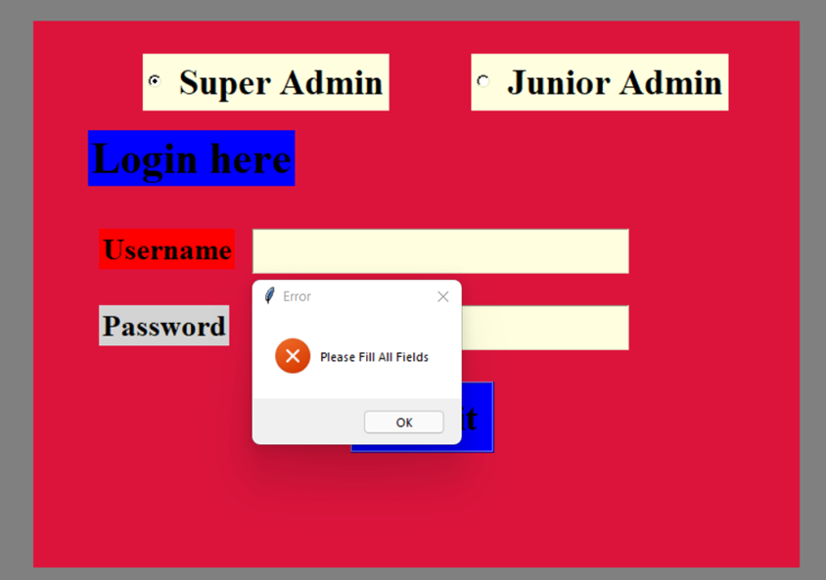

The following error message is displayed if both fields are empty and submit button is clicked

Linked with success criteria 3

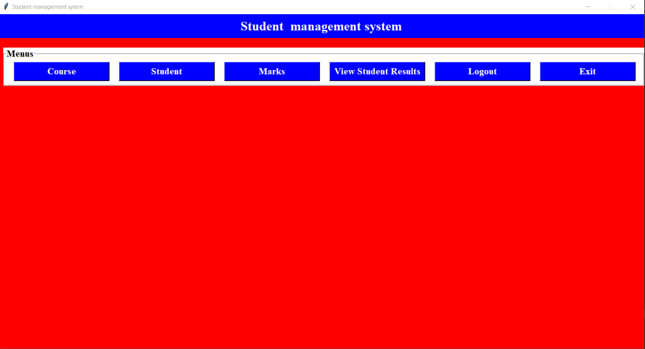

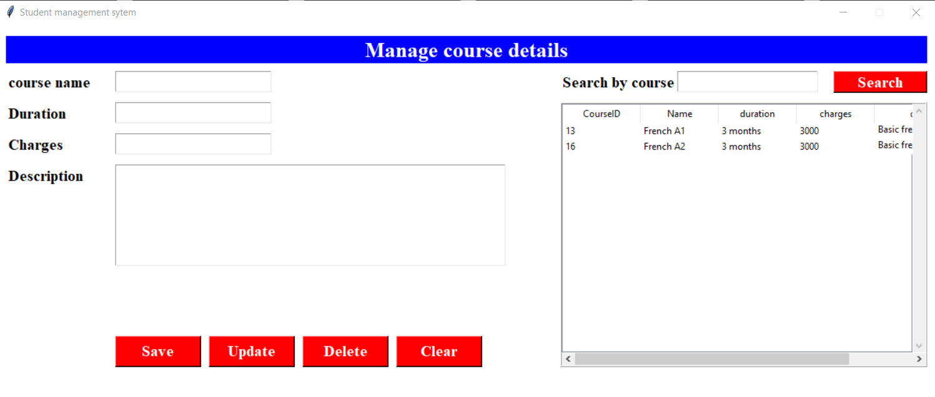



The code for this success criteria is as follows



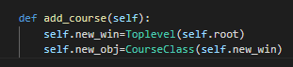

This function was then called on the course button which was created before the function was written this is the code for that



This is the code for the course tab’s structure

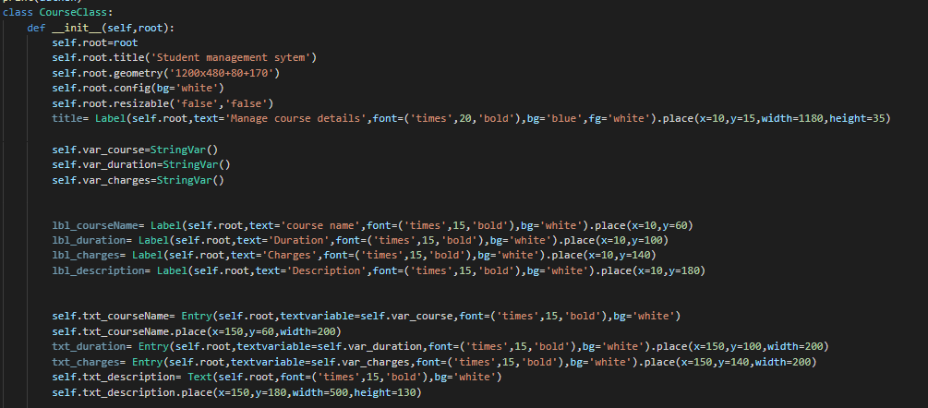



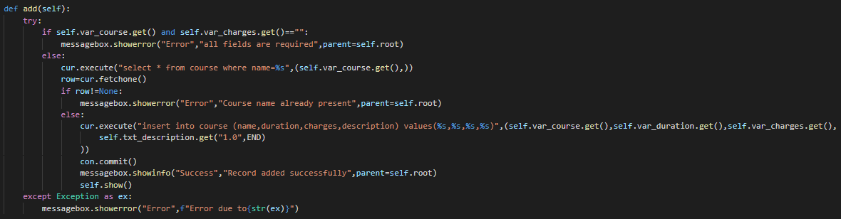

Linked with success criteria 4



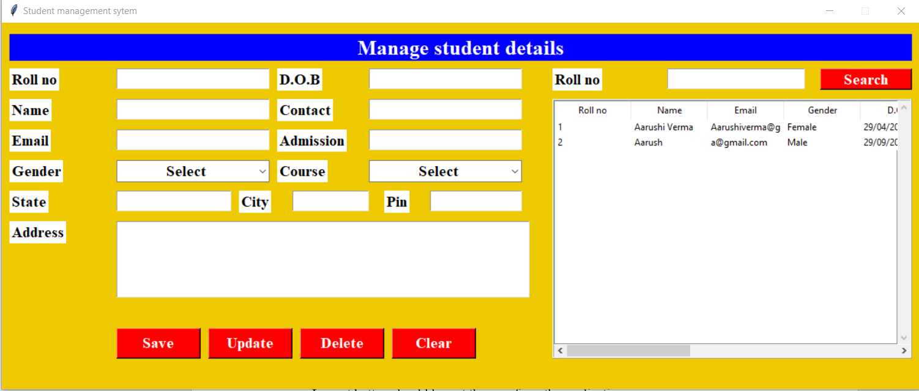

This is the course tab that will be shown to the user once he or she clicks on the student button.

To provide functionality to the student button a new function called add_student was made

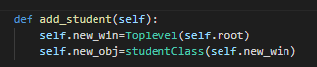

This function was later called on the button



I have used the Abstraction feature of OOPS where I made a class called student class and designed the student tab in it here is the code for the tab

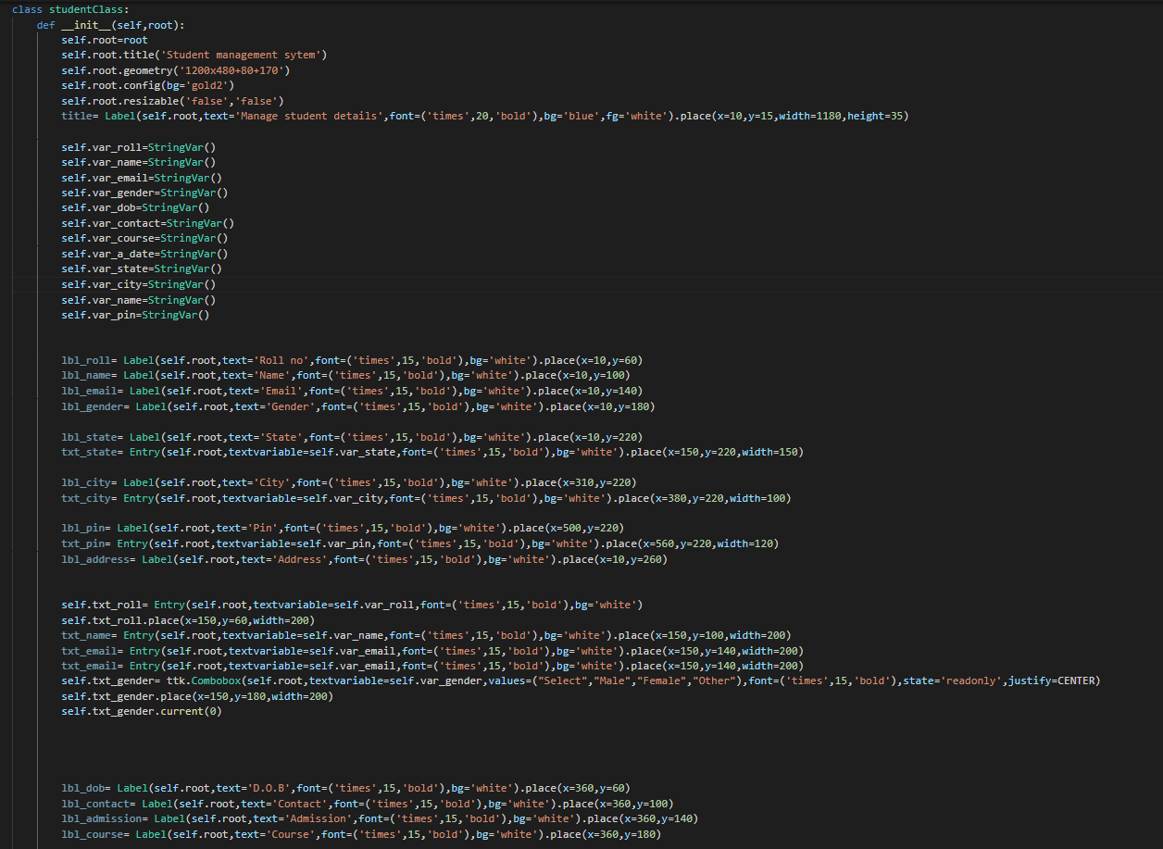

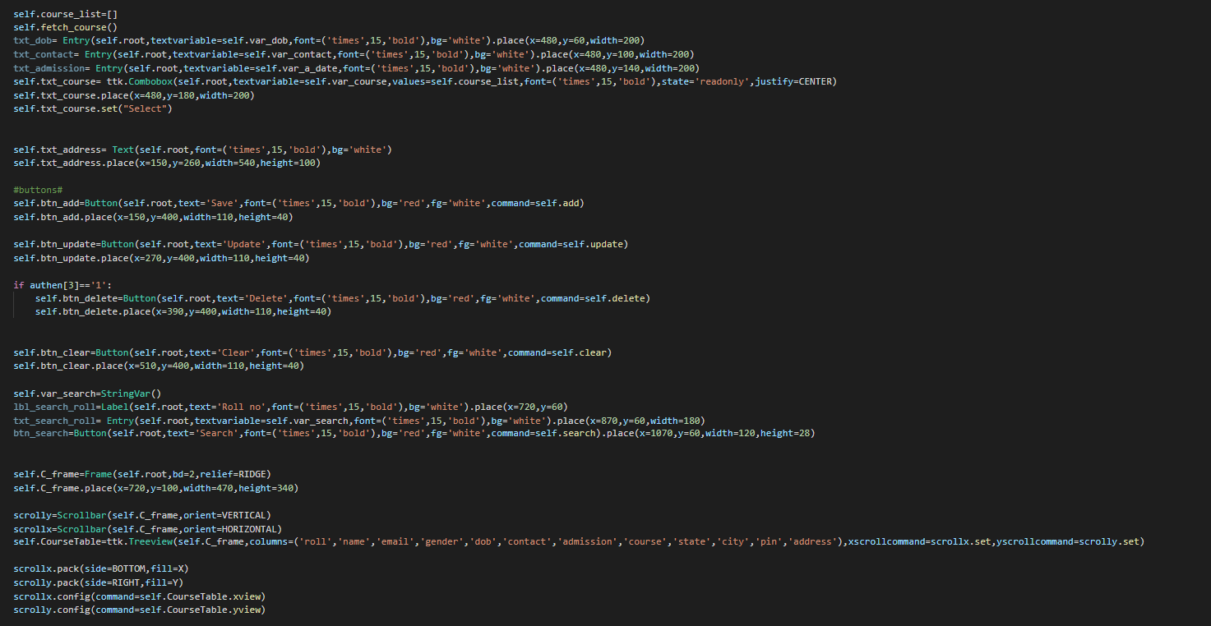

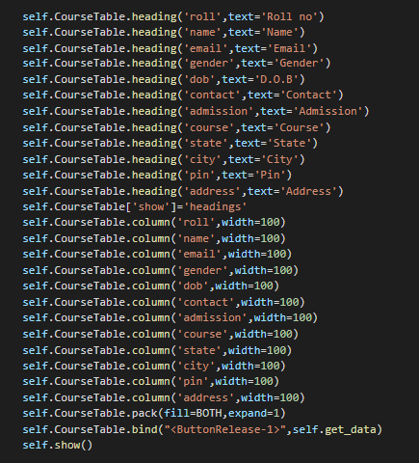

The student class was later imported into the dashboard and the add_student function was written

Linked with success criteria 5



After the user clicks the Marks button the following tab opens

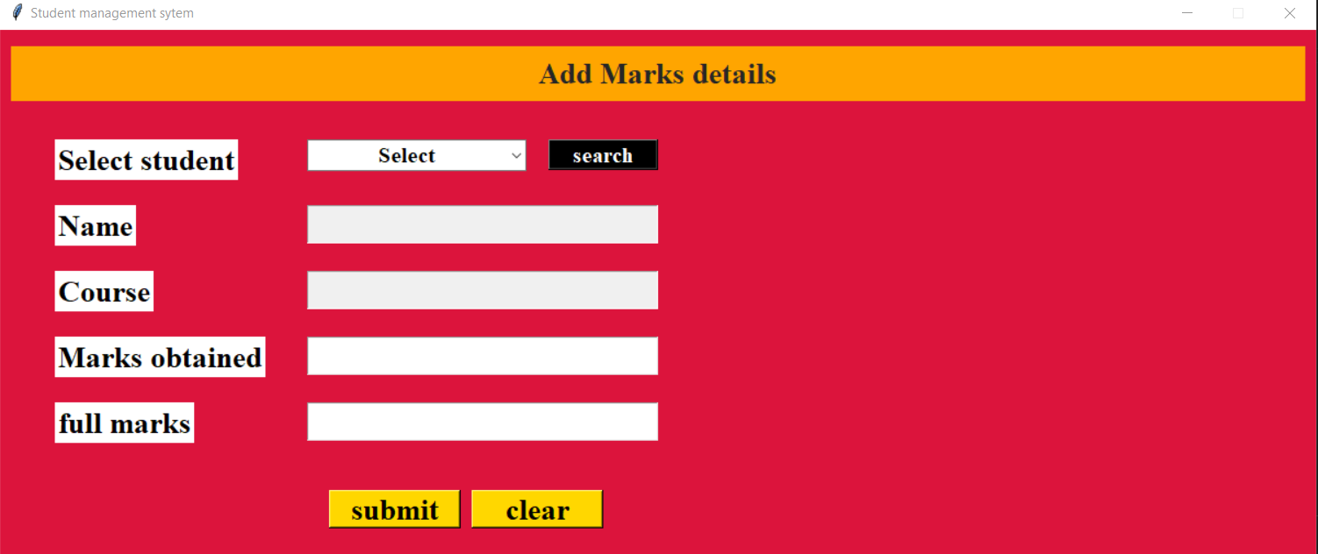

I made a class called resultClass and wrote the code for the entire tab inside this class. The code for the tab can be seen below:

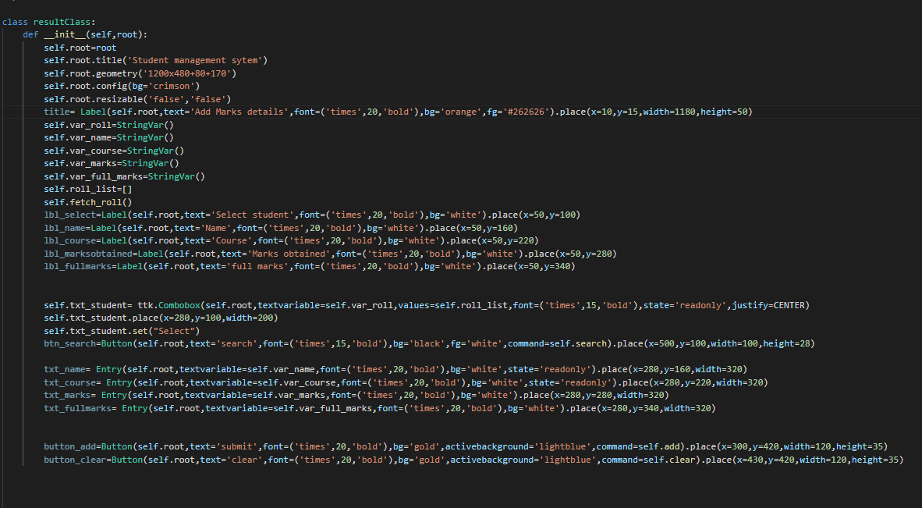

I then imported this class in the dashboard file and after that I made a function called add_result:

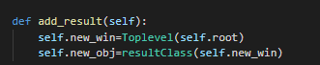

This function was then called on the Marks button the code for that can be seen here





Linked with success criteria 6



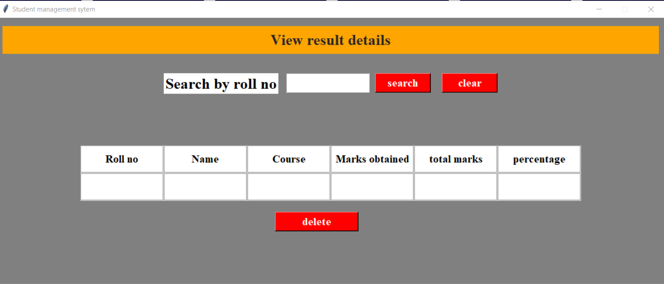

This is the View student results tab which is executed after the user clicks on the view student results button.

First I made a class called the reportClass and I designed the entire system inside it

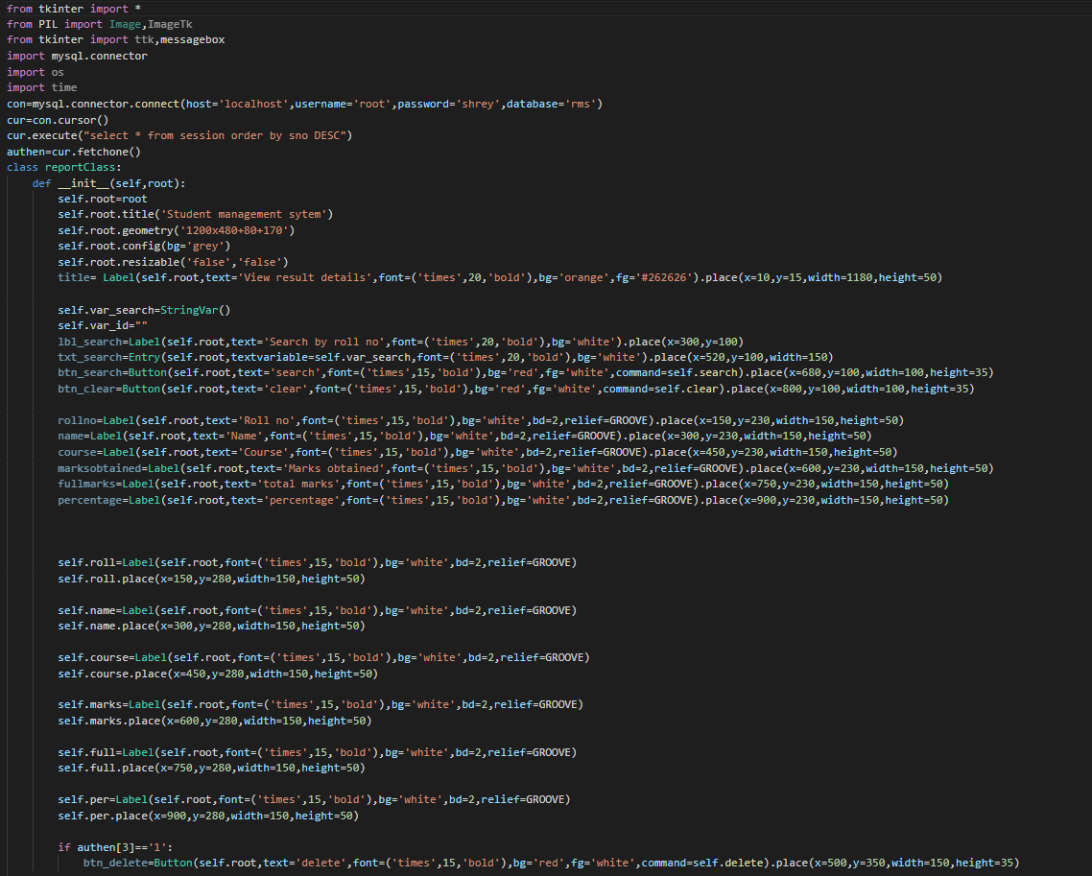

After I completed the design of this tab I imported the class in the dashboard file and made a new function called add_report

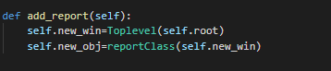



This was then called on the button





Linked with success criteria 7

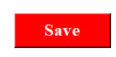

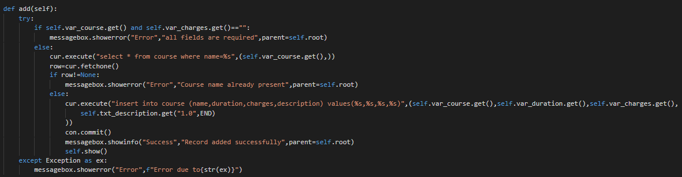



Linked with success criteria 8



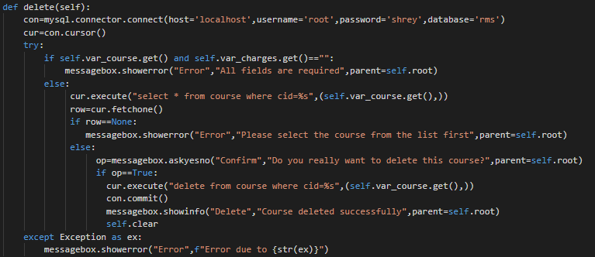



Linked with success criteria 9

This code shows whether the user is a super user or not if the user logs in using super user credentials then the delete button is displayed



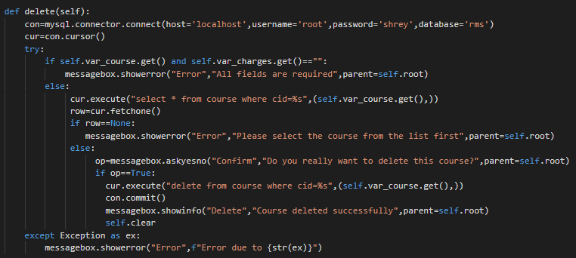





Linked with success criteria 10



This is the update button this also exists in both course and student tab the aim to create this button was to make any changes in the existing data that was previously added using the save button

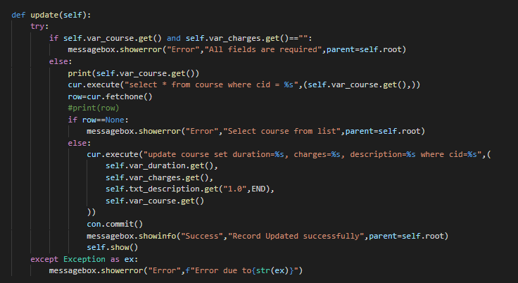





Linked with success criteria 11



This is the clear button this button is placed in the course, student as well as the marks tab this button will hide all the data written in the entry fields and will present blank fields to the user

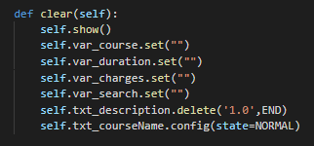

This function has been called on the clear button and that can be understood by the following code:



Linked with success criteria 12



This is the search button of our my system this has been added in the course, student, marks and the view student results tab

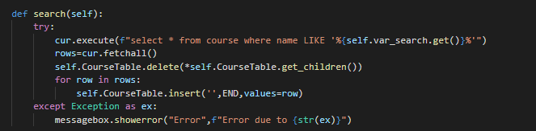

To execute this function it was called on the search button



Linked with success criteria 13





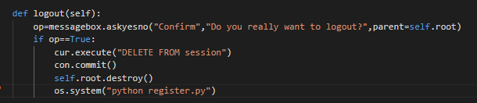

Opens the new login page for the user after logging out

Linked with success criteria 14



